Spring Core and Maven

Exercise 1: Configuring a Basic Spring Application
Scenario: Your company is developing a web application for managing a library. You need to use the Spring Framework to handle the backend operations.

Pom.xml (added dependancies highlighted)
<project xmlns="http://maven.apache.org/POM/4.0.0" xmlns:xsi="http://www.w3.org/2001/XMLSchema-instance"
xsi:schemaLocation="http://maven.apache.org/POM/4.0.0 http://maven.apache.org/maven-v4_0_0.xsd">
<modelVersion>4.0.0</modelVersion>
<groupId>com.library</groupId>
<artifactId>LibraryManagement</artifactId>
<version>1.0-SNAPSHOT</version>
<name>Archetype - LibraryManagement</name>
<url>http://maven.apache.org</url>
<dependencies>
<dependency>
<groupId>org.springframework</groupId>
<artifactId>spring-context</artifactId>
<version>5.3.30</version> <!-- or similar -->
</dependency>
</dependencies>
</project>

Applicationcontext.xml

<?xml version="1.0" encoding="UTF-8"?>
<beans xmlns="http://www.springframework.org/schema/beans"
xmlns:xsi="http://www.w3.org/2001/XMLSchema-instance"
xsi:schemaLocation="
http://www.springframework.org/schema/beans
http://www.springframework.org/schema/beans/spring-beans.xsd">
<bean id="bookRepository" class="com.library.repository.BookRepository"/>
<bean id="bookService" class="com.library.service.BookService"/>
</beans>
BookRepository.java
package com.library.repository;
public class BookRepository {
public void display() {
System.out.println("BookRepository is working.");
}
}

BookService.java
package com.library.service;
public class BookService {
public void serve() {
System.out.println("BookService is working.");
}
}

LibraryManagementApplication.java
package com.library;
import com.library.service.BookService;
import com.library.repository.BookRepository;
import org.springframework.context.ApplicationContext;
import org.springframework.context.support.ClassPathXmlApplicationContext;
public class LibraryManagementApplication {
public static void main(String[] args) {
ApplicationContext context = new ClassPathXmlApplicationContext("applicationContext.xml");
BookService bookService = context.getBean("bookService", BookService.class);
BookRepository bookRepository = context.getBean("bookRepository", BookRepository.class);
bookService.serve();
bookRepository.display();
}
}
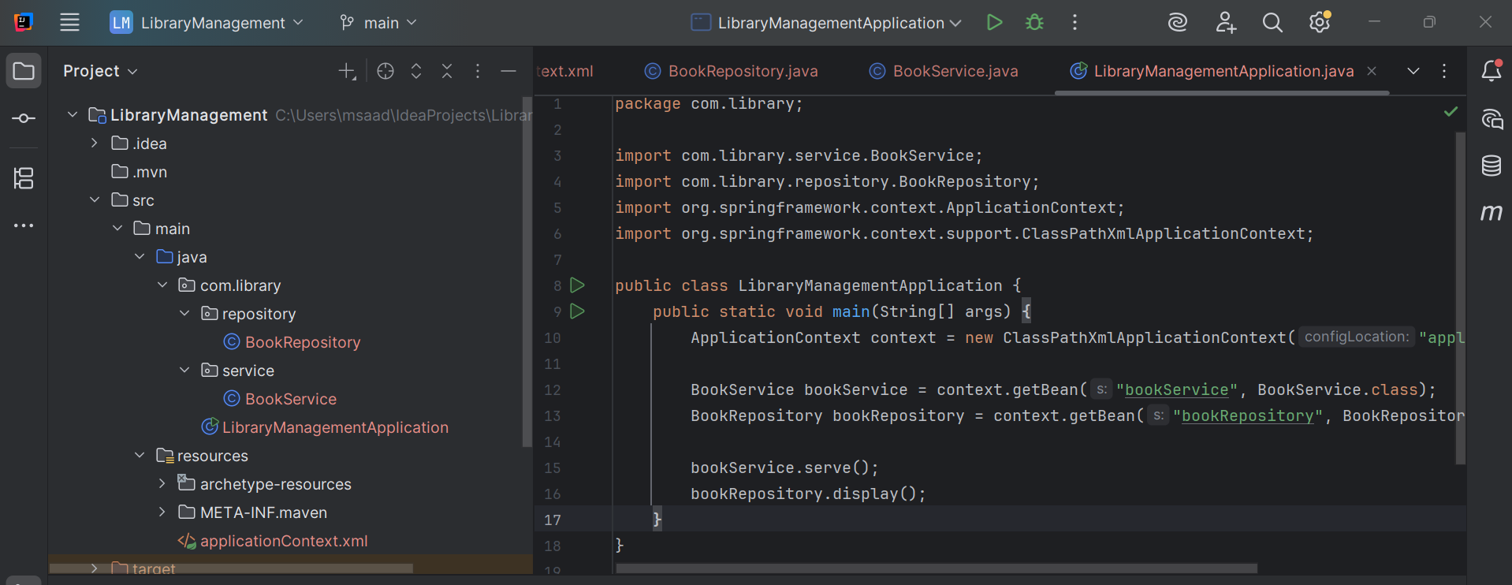

Output:
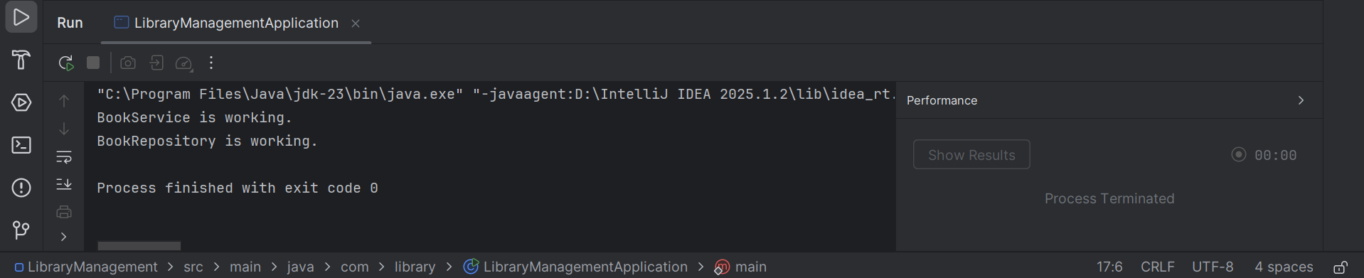

Exercise 2: Implementing Dependency Injection
Scenario: In the library management application, you need to manage the dependencies between the BookService and BookRepository classes using Spring's IoC and DI.

Update the BookService.java
package com.library.service;
import com.library.repository.BookRepository;
public class BookService {
private BookRepository bookRepository;
// Setter for DI
public void setBookRepository(BookRepository bookRepository) {
this.bookRepository = bookRepository;
}
public void serve() {
System.out.println("BookService is working.");
// Use BookRepository to confirm DI works
bookRepository.display();
}
}

Update the applicationContext.xml file:

<?xml version="1.0" encoding="UTF-8"?>
<beans xmlns="http://www.springframework.org/schema/beans"
xmlns:xsi="http://www.w3.org/2001/XMLSchema-instance"
xsi:schemaLocation="
http://www.springframework.org/schema/beans
http://www.springframework.org/schema/beans/spring-beans.xsd">

<bean id="bookRepository" class="com.library.repository.BookRepository"/>

<bean id="bookService" class="com.library.service.BookService">
<property name="bookRepository" ref="bookRepository"/>
</bean>

</beans>

Run the main class
Output:
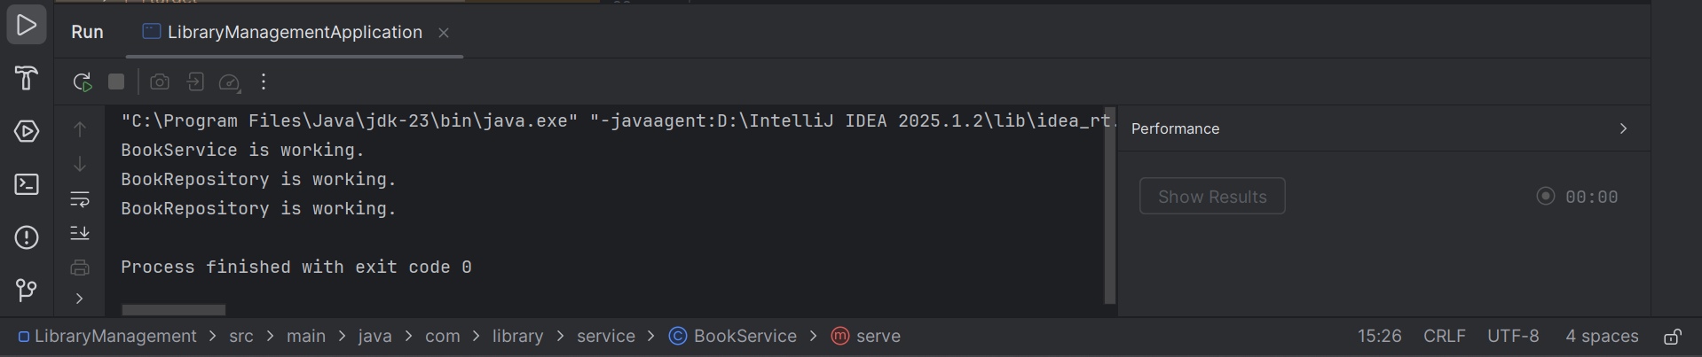

Exercise 4: Creating and Configuring a Maven Project
Scenario: You need to set up a new Maven project for the library management application and add Spring dependencies.

I will add Spring AOP and Spring WebMVC dependencies to the POM file

<dependency>
<groupId>org.springframework</groupId>
<artifactId>spring-context</artifactId>
<version>5.3.30</version> <!-- Or any stable version -->
</dependency>

<dependency>
<groupId>org.springframework</groupId>
<artifactId>spring-aop</artifactId>
<version>5.3.30</version>
</dependency>

<dependency>
<groupId>org.springframework</groupId>
<artifactId>spring-webmvc</artifactId>
<version>5.3.30</version>
</dependency>
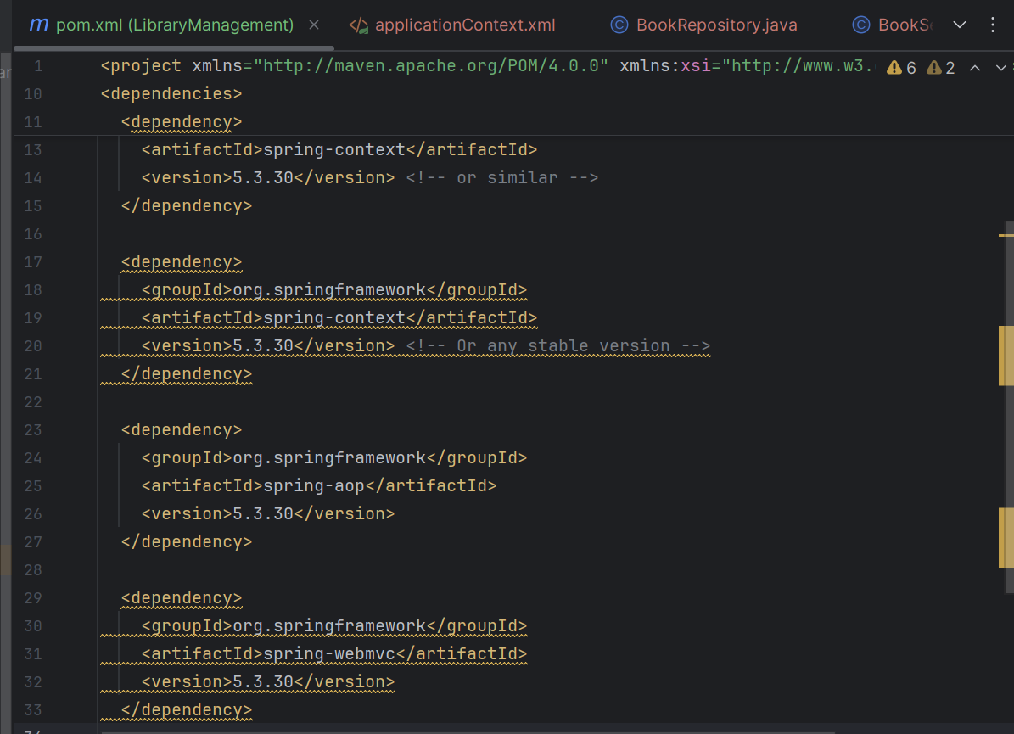

Add the Maven Compiler Plugin:
<build>
<plugins>
<plugin>
<groupId>org.apache.maven.plugins</groupId>
<artifactId>maven-compiler-plugin</artifactId>
<version>3.10.1</version>
<configuration>
<source>1.8</source> <!-- Or 17 if you're using JDK 17 -->
<target>1.8</target>
</configuration>
</plugin>
</plugins>
</build>
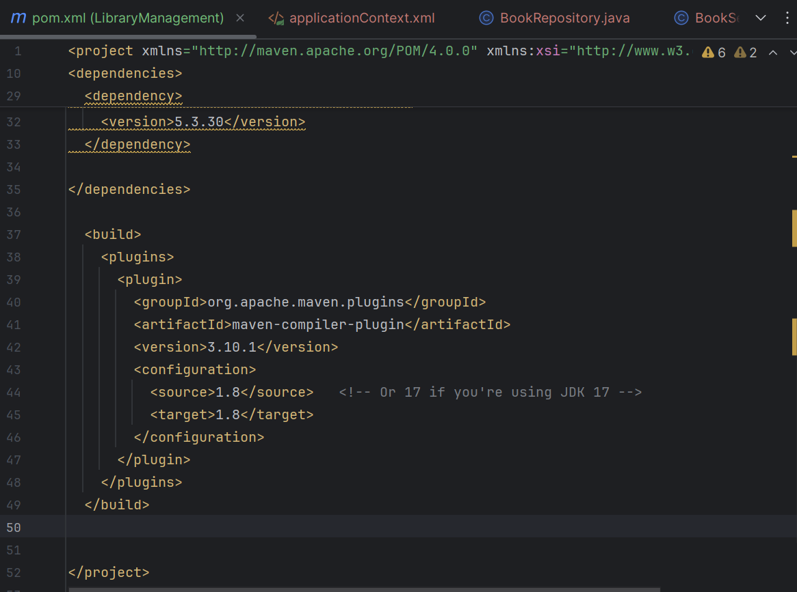

We can see that the plugins are added successfully
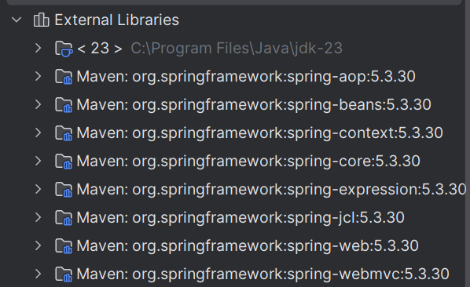

The Maven project is successfully configured now

